COAL LAB 07

23I-0544

MUHAMMAD HAMMAD

BCS-3D

TASK 01:

INCLUDE Irvine32.inc

.data

array1 WORD 1, 2, 3, 4, 5, 6, 7, 8, 9, 10

array2 WORD 11 DUP(?)

.code

main PROC

mov eax, 0

mov ecx, 11

mov esi, 20

L1:

push array1[esi]

sub esi, 2

loop L1

mov ecx, 10

mov esi, 0

L2:

pop array2[esi]

add esi, 2

loop L2

mov ecx, 10

mov esi, 0

L5:

mov ax, array2[esi]

call WriteInt

call Crlf

add esi, 2

loop L5

EXIT

main ENDP

END main

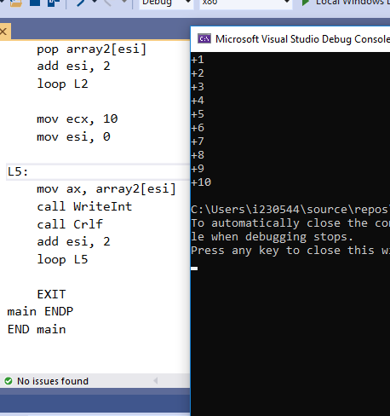

TASK 02:

INCLUDE Irvine32.inc

.data

.code

main PROC

mov eax, 0

mov ecx, 3

L1:

mov ebx, ecx

push ebx

loop L1

mov ecx, 3

mov edx, 0

L2:

pop edx

add eax,edx

loop L2

call WriteInt

call Crlf

EXIT

main ENDP

END main

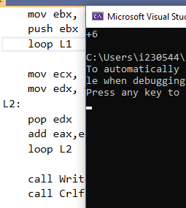

TASK 03:

INCLUDE Irvine32.inc

.data

array1 DWORD 1, 2, 3, 4, 5

array2 DWORD 1, 2, 3, 4, 5

sum1 DWORD ?

sum2 DWORD ?

totalSum DWORD ?

.code

PROGRAM1 PROC

mov eax, 0

mov ebx, 0

mov esi, OFFSET array1

mov ecx, 5

L1:

add ebx, [esi]

add esi, 4

loop L1

mov sum1, ebx

ret

PROGRAM1 ENDP

PROGRAM2 PROC

mov eax, 0

mov ebx, 0

mov esi, OFFSET array2

mov ecx, 5

L2:

add ebx, [esi]

add esi, 4

loop L2

mov sum2, ebx

ret

PROGRAM2 ENDP

PROGRAM3 PROC

mov eax, sum1

add eax, sum2

mov totalSum, eax

ret

PROGRAM3 ENDP

main PROC

call PROGRAM1

call PROGRAM2

call PROGRAM3

call WriteInt

EXIT

main ENDP

END main

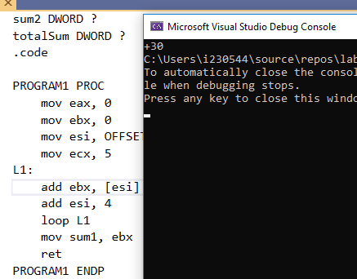

TASK 04:

INCLUDE Irvine32.inc

.data

col DWORD 5

star BYTE "\*", 0

space BYTE " ", 0

stars DWORD 1

spaces DWORD 4

.code

pattern PROC

mov eax, 0

mov edx, 0

mov ebx, 5

mov ecx, col

L:

push ecx

mov ecx, ebx

L1:

mov edx, OFFSET space

call WriteString

loop L1

sub ebx, 1

mov ecx, stars

mov edx, OFFSET star

L2:

call WriteString

loop L2

call Crlf

inc stars

pop ecx

loop L

ret

pattern ENDP

main PROC

call pattern

EXIT

main ENDP

END main

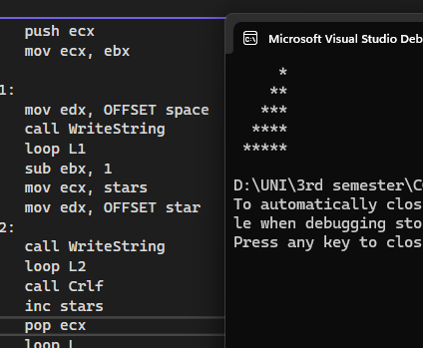

TASK 05:

INCLUDE Irvine32.inc

.data

prompt1 BYTE "Enter the number to which you want sum of: 1 to n :",0

.code

asknum PROC

mov edx, OFFSET prompt1

call writeString

call readint

mov ecx, eax

mov eax, 0

L:

add eax, ecx

loop L

ret

asknum ENDP

main PROC

call asknum

call WriteInt

call Crlf

EXIT

main ENDP

END main

